Outdoor Football MODEL FB-303

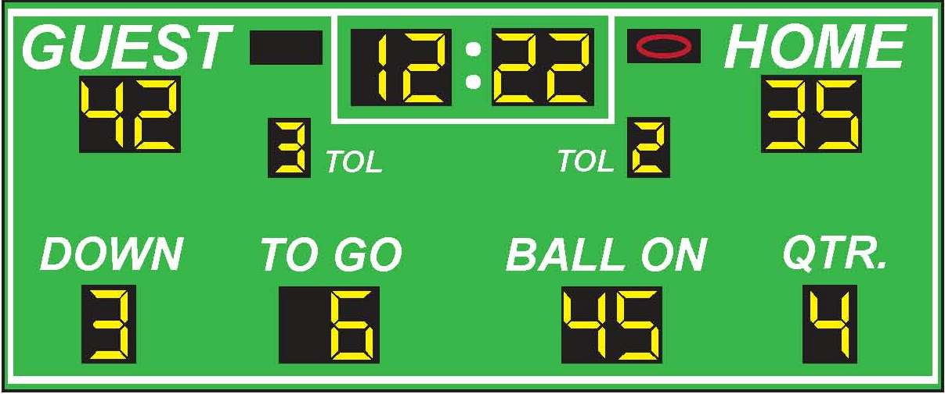

SPECIFICATIONS
Dimensions: Width: 32ft Height: 10ft
Weight: 750 lbs
Electrical: 5 Amps, 120 VAC
Display Material: Aluminum
Information Displayed: GAME TIME, GUEST, HOME, TIME OUTS LEFT, DOWN, TO GO, BALL ON, QUARTER, POSSESSION
Caption Height: 15 in, 12 in, 9 in
Caption Material: Vinyl
Digit Height: 24 in, 18 in
Digit Colors: Amber or Red
Controller: Easy to use (light weight and portable)

Model 13248 Features
- Choice of standard paint colors
- Scoreboards are painted with long lasting enamel based paint
- Choice of red or amber LED displays
- All aluminum construction
- Mounting hardware is supplied for permanent installations on customer provided supporting posts.
- All LED display circuit boards are conformal coated for outdoor protection.
- Five year limited warranty
- Lifetime technical support by phone or e-mail
Optional Features
- Additional warranty or support plans
- Full color video displays
- Single color electronic team names instead of guest and home
- Up to 1,000 feet of data cable
- Wireless communication system
- Custom paint colors
- Separate ID panels with specific pictures, texts, and graphics that can be mounted on the top, side or bottom, of the board.

