Indoor Basketball MODEL BK-303

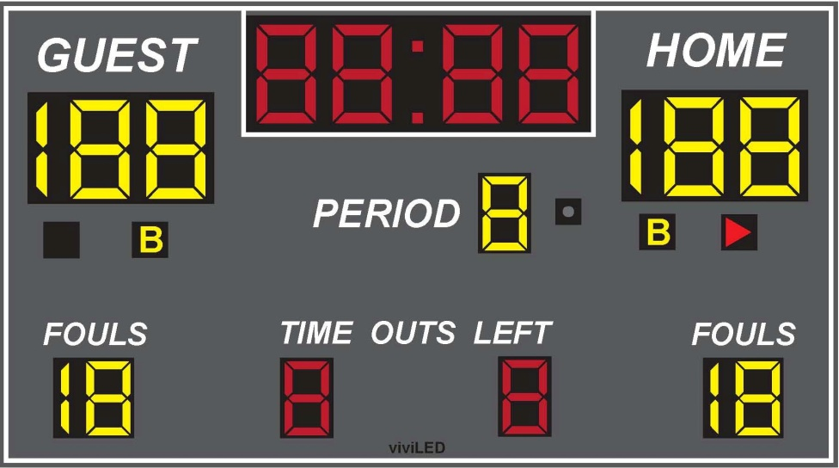

SPECIFICATIONS
Dimensions: Width: 9ft Height: 5ft
Weight: 135 lbs
Electrical: 3 Amps, 120 VAC
Display Material: Aluminum
Information Displayed: GAME TIME, GUEST, HOME, PERIOD, FOULS, TIME OUTS LEFT, BONUS, POSSESSION, HORN
Caption Height: 5 in, 4in, 3in
Caption Material: Vinyl
Digit Height: 12 in, 9 in
Digit Colors: Amber or Red
Controller: Easy to use (light weight and portable)

Model 13248 Features
- Choice of standard paint colors
- Scoreboards are painted with long lasting enamel based paint
- Choice of red or amber LED displays
- All aluminum construction
- Mounting hardware is supplied for permanent installations.
- Five year limited warranty
- Lifetime technical support by phone or e-mail

Optional Features
- Additional warranty or support plans
- Full color video displays
- Single color electronic team names instead of guest and home
- Up to 1,000 feet of data cable
- Wireless communication system
- Custom paint colors
- Separate ID panels with specific pictures, texts, and graphics that can be mounted on the top, side or bottom, of the board.

