Outdoor Baseball MODEL BB-103

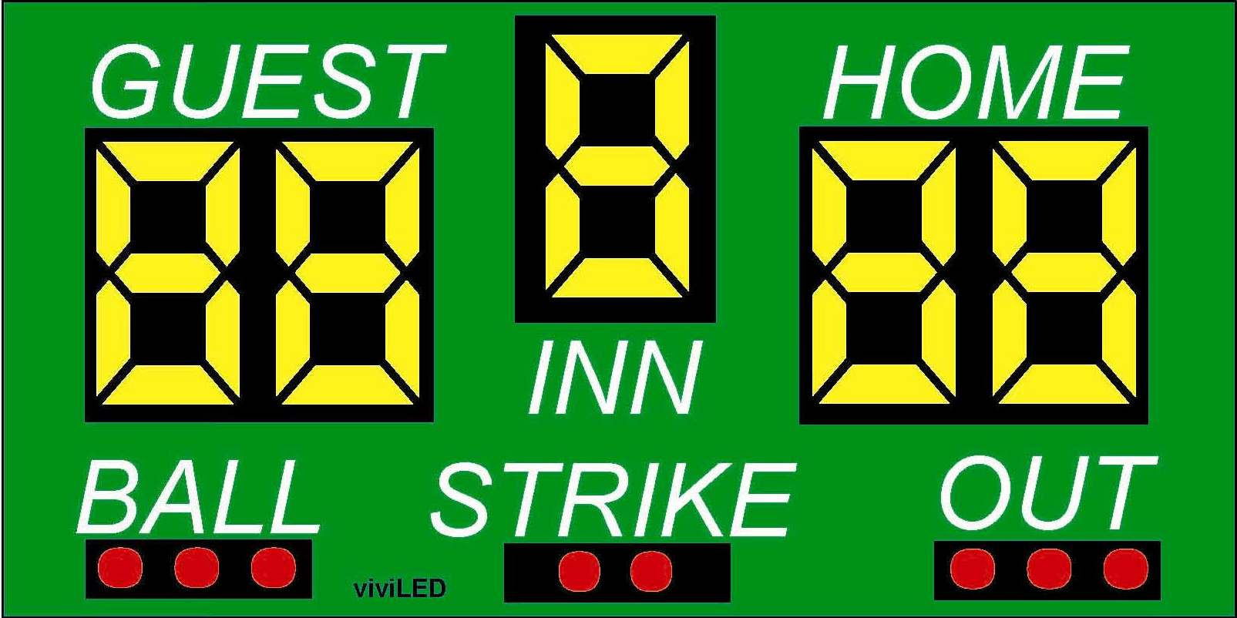

SPECIFICATIONS
Dimensions: Width: 8ft Height: 4ft
Weight: 110 lbs
Electrical: 2 Amps, 120 VAC
Display Material: Aluminum
Information Displayed: GUEST, HOME, INN, BALL, STRIKE, OUT.
Caption Height: 8 in
Caption Material: Vinyl
Digit Height: All digits are 18 in
Digit Colors: Amber or Red
Controller: Easy to use (light weight and portable)

Model 13248 Features
- Choice of standard paint colors
- Scoreboards are painted with long lasting enamel based paint
- Choice of red or amber LED displays
- All aluminum construction
- Mounting hardware is supplied for permanent installations on customer provided supporting posts.
- All LED display circuit boards are conformal coated for outdoor protection.
- Five year limited warranty
- Lifetime technical support by phone or e-mail

Optional Features
- Additional warranty or support plans
- Full color video displays
- Single color electronic team names instead of guest and home
- Up to 1,000 feet of data cable
- Wireless communication system
- Custom paint colors
- Separate ID panels with specific pictures, texts, and graphics that can be mounted on the top, side or bottom, of the board.

